Belridge Secondary College
BYOD (Bring Your Own Device)
Installing Microsoft Office to your device

Students and staff with a Department of Education login ID can install Microsoft Office applications on up to 15 personally owned devices (five Windows devices, five Apple OSX devices and five mobile devices).
Important, please note: Before installing Microsoft Office to your BYOD device, you must have an active mailbox in Connect.
To install the software:
- Log in to Connect https://connect.det.wa.edu.au
- Load your email inbox
- Click on the small squares at the top left hand side of your mailbox
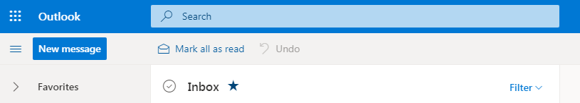
A sidebar will appear showing a selection of Online Microsoft apps.......
Click the words Microsoft 365 above the app listing.
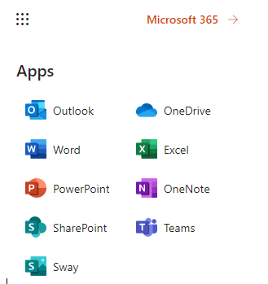
This will bring you to a screen where you can install the Microsoft Office software.
Click on the Install Office drop down menu to select the installation option you require and follow the prompts.
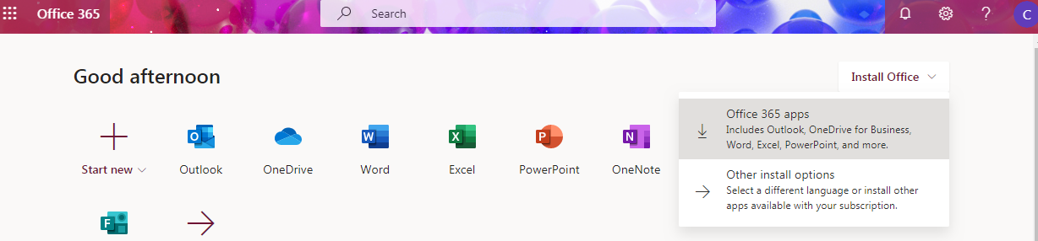

From time to time the Microsoft suite will ask you to confirm your identity by showing a mini sign in window (this will often happen after you have had a password change).
Enter your network username and current password to continue.
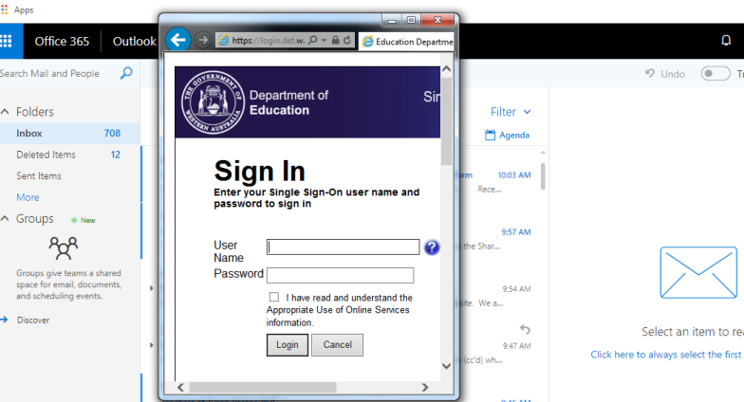
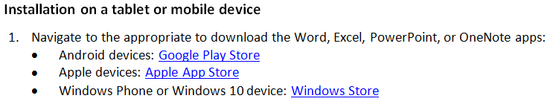
Detailed guides to obtaining and installing the software on phones and tablets (including email set-up) can be found at https://support.office.com/en-us/article/Set-up-Office-apps-and-email-on-a-mobile-device-7dabb6cb-0046-40b6-81fe-767e0b1f014f?ui=en-US&rs=en-US&ad=US

For help with the Microsoft applications, go to https://support.office.com

